- Write in a standard form
  - $\frac{3.5}{{10}^{6}}$ b. $0.000034×{10}^{b}$

- $245×{10}^{a}$ d. $\frac{3.9}{{10}^{-4}}$ $0.000034×{10}^{b}$

- Give your answers in standard form
$a. \left(7×{10}^{a}\right)×\left(6×{10}^{b}\right)$ b. $\left(4×{10}^{a}\right)÷\left(5×{10}^{b}\right)$
- Give your answers in standard form
$a. \left(5.2×{10}^{a+2}\right)+\left(2.1×{10}^{a}\right)$ b. $\left(6.4×{10}^{a+1}\right)-\left(2.9×{10}^{a}\right)$
- Solve the following inequality and show the answers on a number line.
$1+4\left(x+4\right)<2+5\left(3x-1\right)≤8x+13$
- Solve the following equations
- $3{(x}^{2}-4)=15$ b. $2\sqrt{4+x}+3=9$
- Add the following algebraic fractions
  - $\frac{2-2x}{5}-\frac{3x-y}{4}-\frac{x-5y}{10}$ b. $\frac{5}{7a}+\frac{6}{35b}-\frac{9}{10ab}$
- Simplify the following algebraic fractions
  - $\frac{10x^{2}y^{3}}{9\sqrt{x^{8}}}×\frac{(2x{y^{2})}^{3}}{4xy^{3}}$ b. $\frac{8x^{5}\sqrt{y^{2}}}{x\sqrt{y^{4}}}÷\frac{14x^{3}y^{2}}{(2{x)}^{3}}$
- Simplify the following algebraic fractions
  - $\frac{2x^{3}y^{3}-6yx^{5}}{8x^{2}y^{3}}$ b. $\frac{7x^{3}y^{4}-35x^{2}y^{5}}{10{xy}^{2}-2x^{2}y}$
- Find the equation of the line on the diagram below
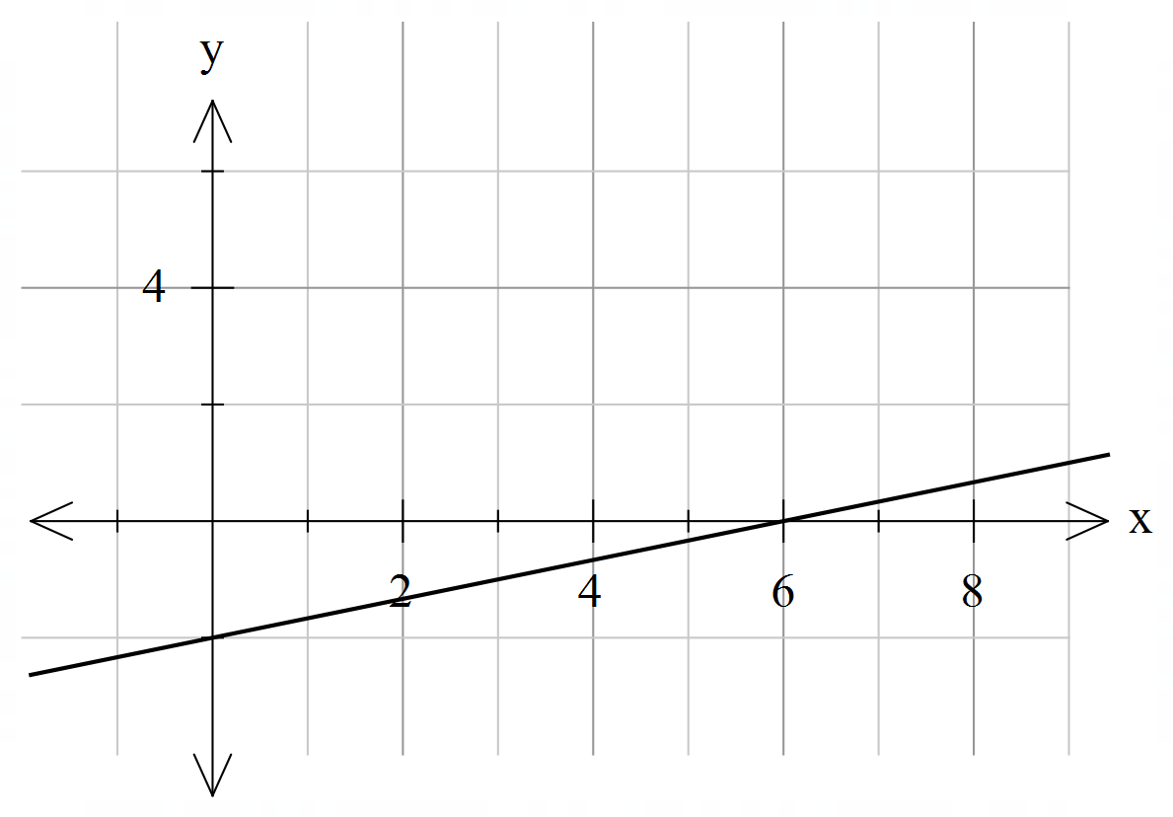
- Gradient of line passing through the points $(-5, 7)$ and $\left(-3, b\right)$is 6. Find the value of $b$.
- Find the gradient and $y-$intercept of the line $5y+7x=3$.
- Find equation of line parallel to line $y=-\frac{3}{4}x+1 ,$ and passing through point $(12, -5)$.
- a. Find the $x-$ and $y-$intercepts of line $4y+8x=24$.
b. Hence sketch the line.
- a. Draw lines $y=\frac{1}{3}x+1$ and $y=-\frac{1}{2}x+5$ on the same set of axes: 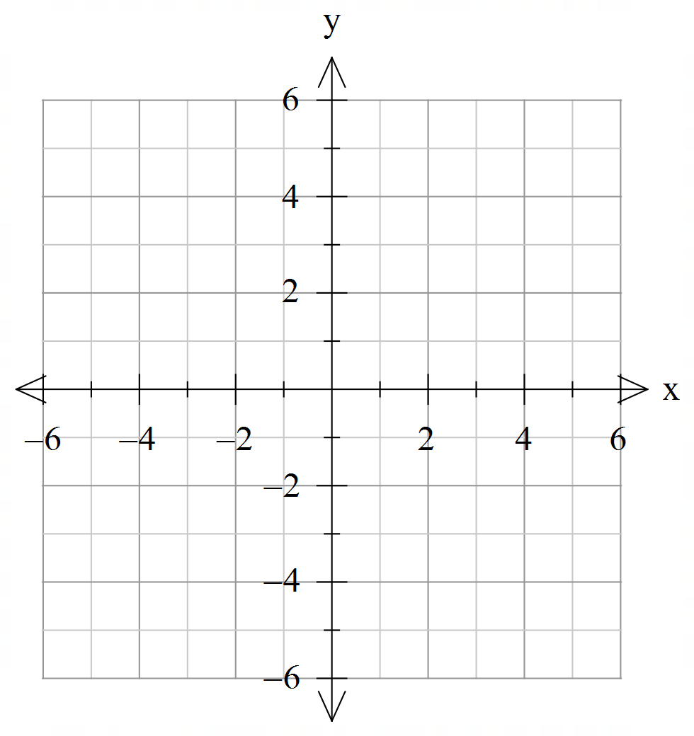
- Hence solve simultaneous equations graphically, using your graph.
$$y=-\frac{1}{2}x+5$$
$$y=\frac{1}{3}x+1$$
- Find the missing side length in the diagram.
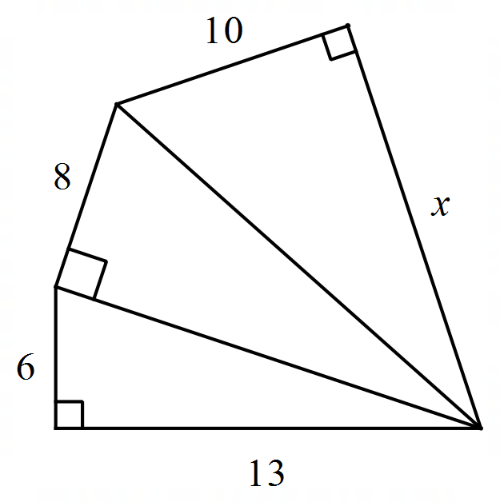
- Find the angle $x$, clearly state the reasoning.
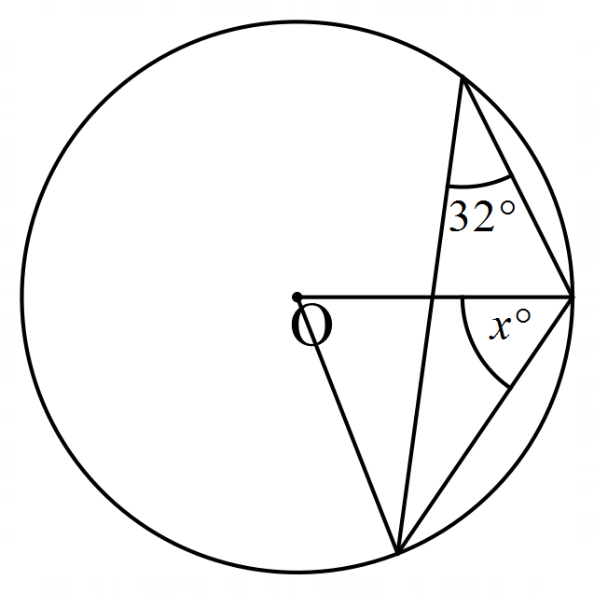
- Solve the following equations
  - $\frac{1}{2}\left(x+3\right)-\frac{1}{3}\left(x-2\right)=\frac{1}{6}(4-2x)$ b. $\frac{x+1}{x-2}+\frac{2}{5x}=1$

- Solve the following simultaneous equations.

$3x+4y=5$ $5x+7y=39$
$2x-3y=3$ $x=2y+1$

